**Territory Optimization Solution**

**1. Branch Performance view:**

This view shows Performance of Branch, here user can check the how branch is performing by looking at Attainment, Revenue potential & construction non-construction activations etc.

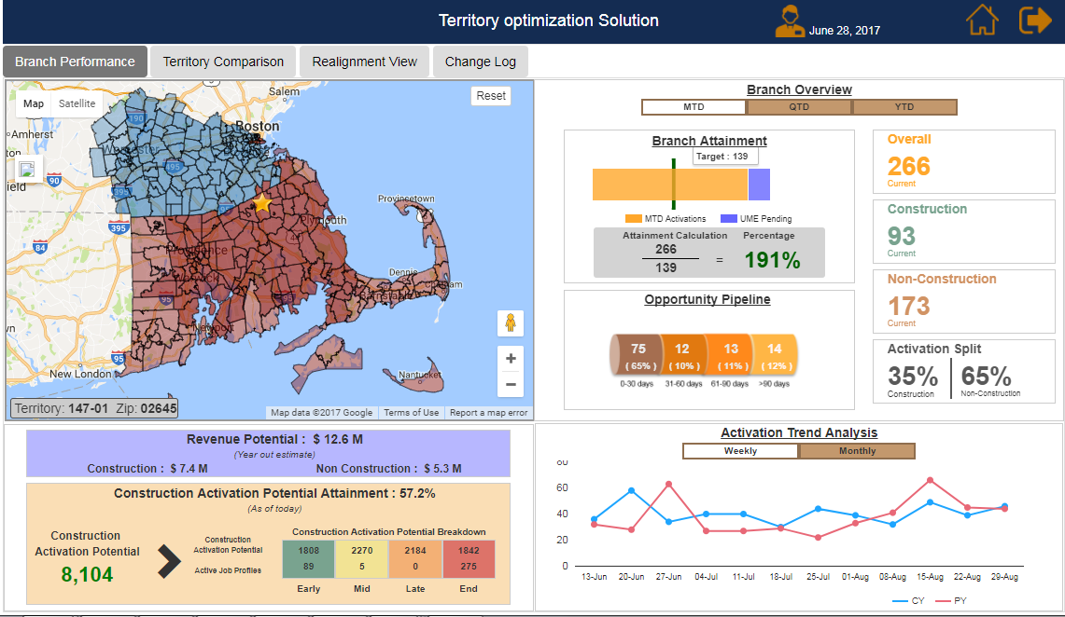

**2.Territory Comparison View:**

Shows territory performance, Here user can compare territories with different metrics like Activations, attainment etc.

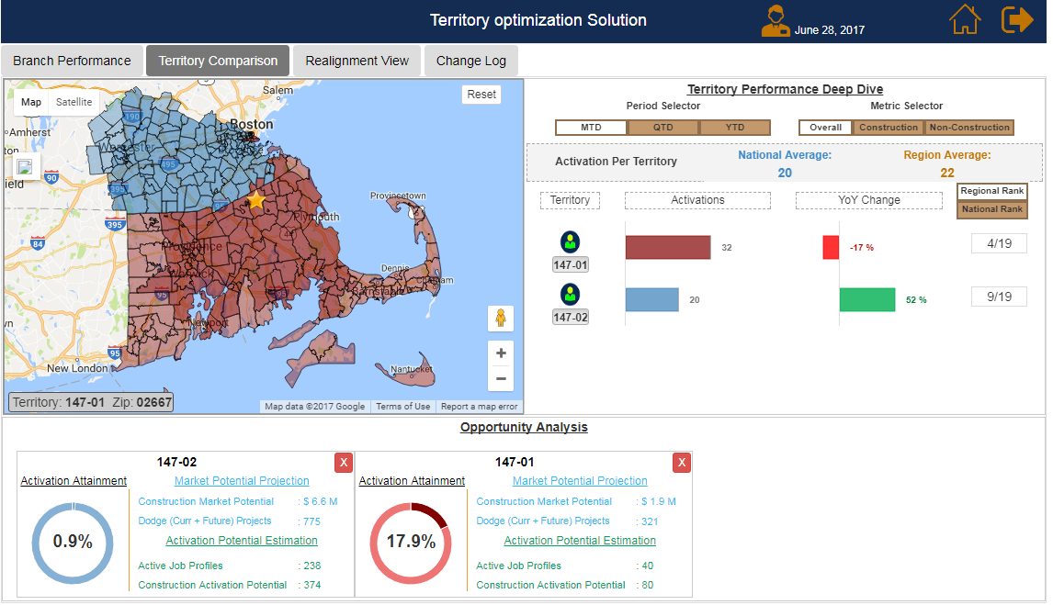

**3.Realignment View:**

In this view user, can compare territories and realign zips between territories.

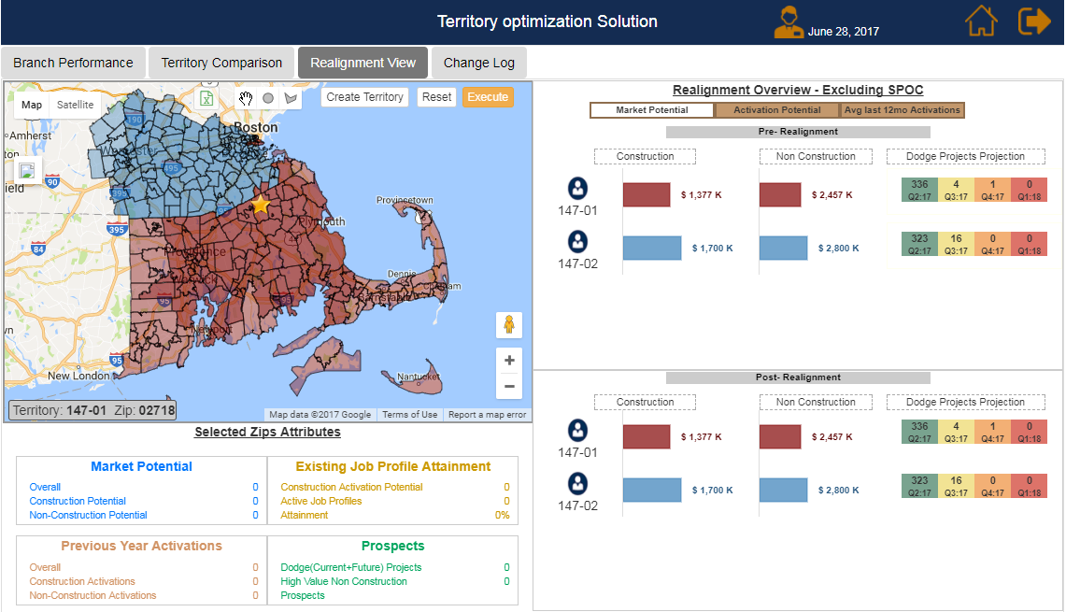

**4.Change Log View:**

It’s a report showing the changes made by the user.

